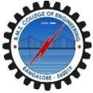 | BMS COLLEGE OF ENGINEERING, BENGALURU - 19  (Autonomous Institute, Affiliated to VTU)  BMSCE ACM STUDENT CHAPTER

ACTIVITY REPORT
on

FLAG HEIST 2.0

- Name of the Department: BMSCE ACM STUDENT CHAPTER
- Name of the Activity: FLAG HEIST 2.0
- Objectives: The objective of the event was to provide a platform for students to showcase their mathematical skills, visualization and problem- solving skills in a given time bound.
- Date, Time Venue of the Activity:
DATE/DAY | Friday, 6th December, 2024.
TIME | 10am- 1pm
VENUE | CSBS Lab, 6th Floor, Department of Computer Science and Business Systems, Platinum Jubilee Academic Block
- Name and details of collaborating agency (if it is collaborative/joint activity): This event was conducted by BMSCE ACM STUDENT CHAPTER on occasion of Phase Shift 2024.

- Brief summary of the Programme: The Flag Heist 2.0 event was structured as follows.
- Bases: Multiple bases were set up, each represented by a Google Form containing a series of questions. The bases consisted of questions related to the following topics: tech based questions, coding based, Phase Shift theme based, logical reasoning, quantitative analysis, mini games, riddles, case-study tech based.
- Capture: Participants were required to answer all the questions in a base to successfully capture it, even if one answer was wrong the base could not be captured.
- Flag Points: The flags used were blue, pink, and yellow, indicating 50, 30, and 10 points, respectively. Participants could win the flags by submitting the forms as fast as possible. When a particular base was considered, the team that captured it first won the blue flag with the maximum points, i.e. 50. The team that captured the same base after it had already been captured by another team won a pink flag with 30 points. The same applied to the yellow flags.
- Time Limit: Participants had a designated time limit of one hour fifteen minutes to capture as many bases as possible. There was no time limit for a particular base.
- Outcomes: The event successfully created an engaging and competitive atmosphere for participants. By combining knowledge-based challenges, teamwork, and a time-bound capture system, the event promoted critical thinking, collaboration, and healthy competition. Participants not only had a chance to showcase their skills but also learned and expanded their knowledge base. The event undoubtedly left a lasting impression on all participants and will be remembered as a thrilling and intellectually stimulating experience

- Number of participants:
Number of Faculty | Number of  Non-Teaching Staff | Number of Students | Number of Volunteers
0 | 0 | 60 | 10

- Relevant Photographs of the activity: (Geo-tagged photos are preferable)

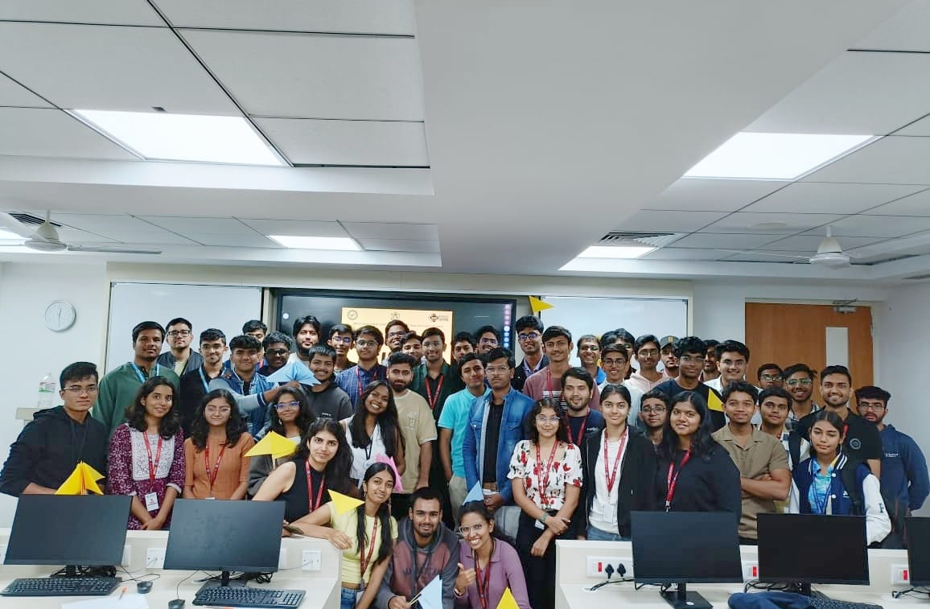
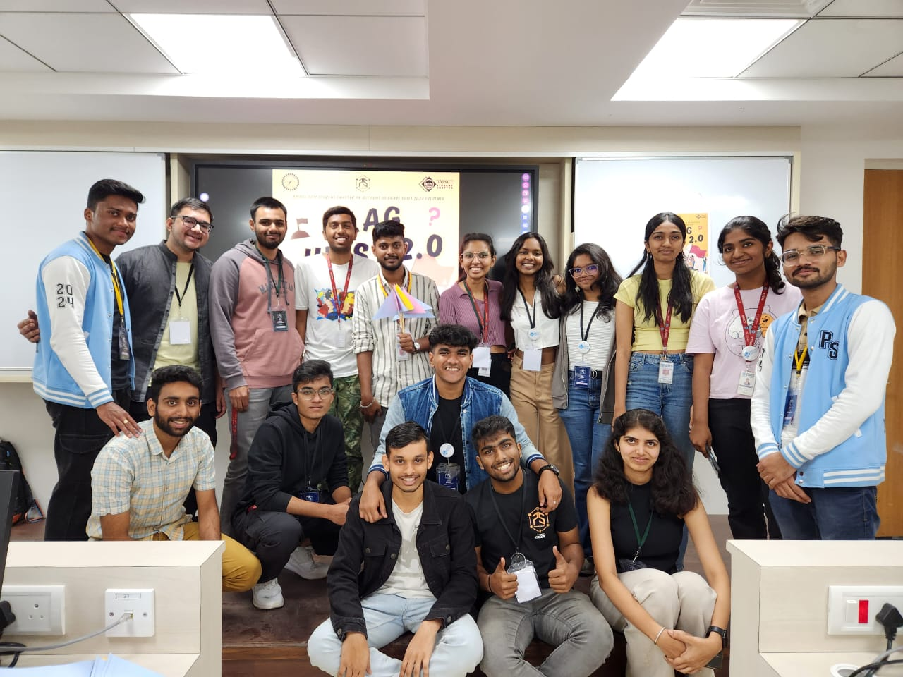

Supporting Documents
a) Attendance sheet
b) Circulars/Brochures

